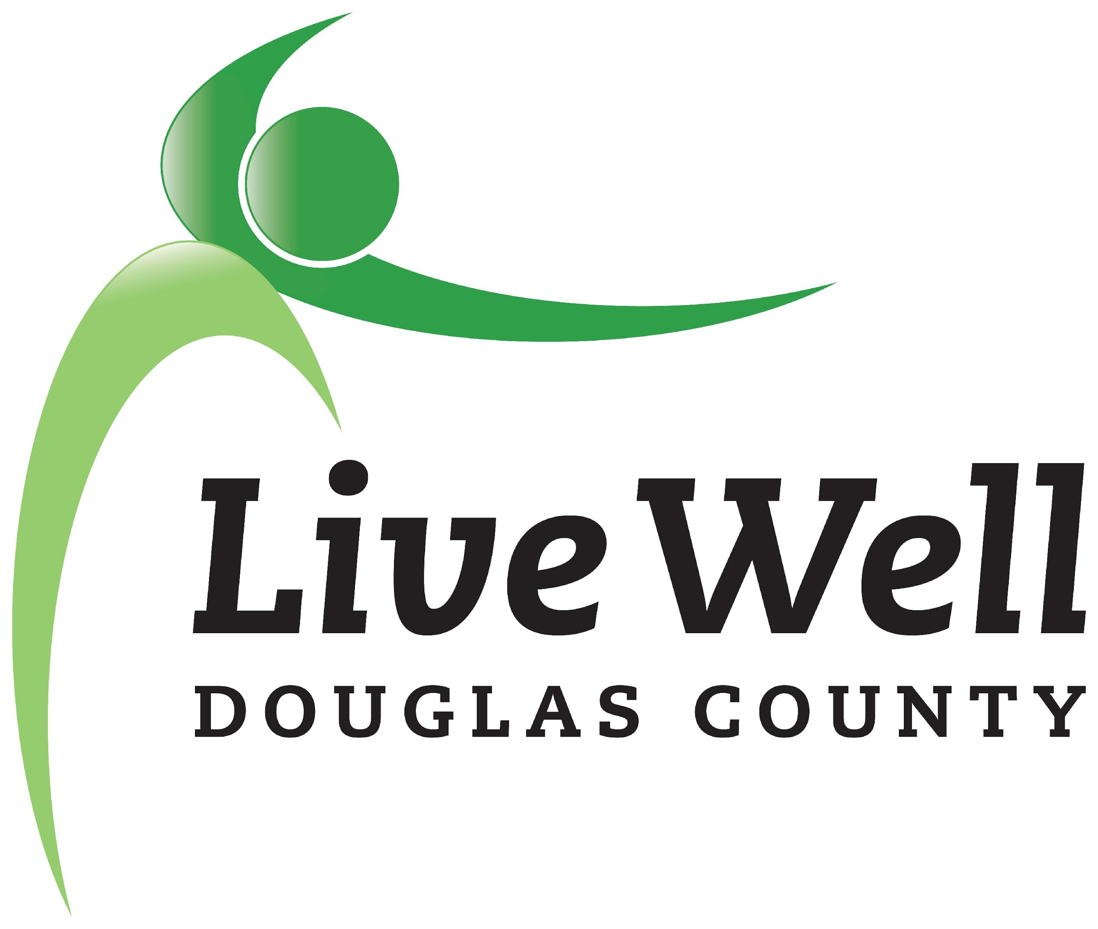
LiveWell Executive Team
Meeting Agenda

June 11, 2020, 3:30-5:00pm
Online via Zoom

Item | Notes | Action step
Review of agenda | - Any additions?
LiveWell Chair Elect position | - Chris Tilden | Joey will reach out to Chris.
Transition | - Training during next leadership team meeting – cover Community Health Plan, WorkStation, Community Check Box.  - Hold a retreat for agenda setting?  - Conduct an equity workshop, perhaps during the second leadership team meeting? LDC PH – could do training on Health Impact Assessment Equity Tool. Also, Sonia presentation on equity in Dg Co. (LDC PH exploring HIP training for steering committee and convener structure and staff.) – Invite the whole coalition.  - Newsletter – meet the new LiveWell leadership?
Review Leadership Team meeting agenda | - When to review/ reflect on CCB data?
Bylaws | - Will review at Friday’s Leadership Team meeting
Equity | - Continue to raise with leadership team and within work groups, and use to help prioritize
Meeting schedule | - Dates for next meetings
Closing

Other potential items:

Following up re: stakeholder engagement | Reviewed conversation from last meeting:  - Past follow-up; may rethink timing: Reach out to Craig to set up a meeting. Joey will draft letter (that can in time be adapted to reach out to the new City Commissioners, as well). Send 10-year report with a letter and offer to meet.  - Could ask to schedule zoom calls. Let them know we are a resource. Have some talking points from the WGs, show what we are doing and offer support. Could also update on grant. Reach out before June, when staff start putting together budget.  - Aspiration: have a closer working relationship with the City  Have the conversations where we have the relationships to have them. | Joey will draft letter.
Capacity building training needs | Add to next agenda. Possible ideas:  - Effective stakeholder engagement, especially city staff. Increasing participation and membership?  Advocacy?
Proactive policy agenda | Will need to add to next agenda.
Director search | Will need to circle back to LDC PH and DCCF re: funding if we receive Pathways grant | Marlin will draft something for consideration

